**Requirement.txt**

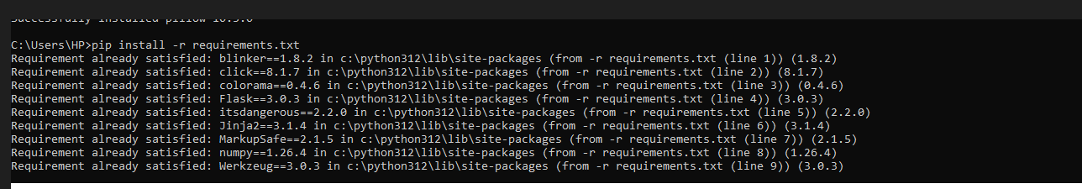

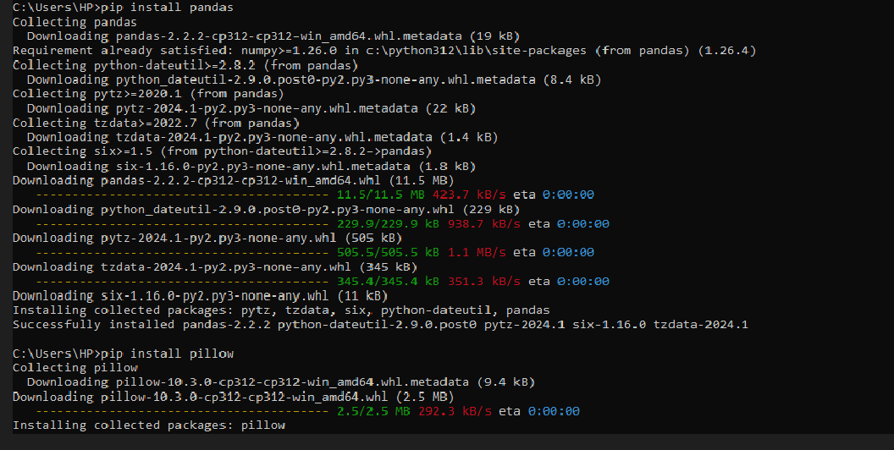

**Flask module:**

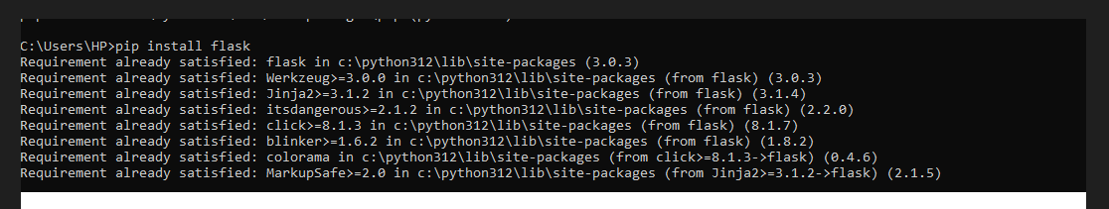

Music Program:

<!DOCTYPE html>

<html lang="en">

<head> <style>

/* Styling the body */

* {

padding: 0;

margin: 0;

}

/* Styling the background image by

giving its url and position */

.container {

height: 100vh;

width: 100%;

background-image: url(

'https://media.geeksforgeeks.org/wp-content/uploads/20210402235143/background.jpg');

/* Image used: */

background-size: cover;

background-position: center;

position: relative;

}

/* Styling the list tags to the

right of the navigation bar */

.nav li {

float: right;

list-style: none;

}

/* Styling the anchor tags of

the navigation bar */

.nav a {

list-style: none;

height: 50px;

line-height: 50px;

font-size: 1rem;

font-weight: 550;

display: block;

padding: 5px 35px;

color: black;

text-decoration: none;

}

/* Giving position and margin

to the content-div */

.content {

width: 100%;

position: absolute;

top: 45%;

}

/* Styling the left-col by

giving margin */

.left-col {

margin-left: 11%;

}

/* Styling the my sound placed

in the left-col */

.left-col h1 {

font-size: 50px;

color: crimson;

}

/* Styling the right-col */

.right-col {

float: right;

margin-right: 10%;

margin-top: -5%;

display: flex;

align-items: center;

}

/* Styling the text in the right-col */

.right-col p {

font-size: 21px;

color: black;

font-weight: 650;

margin-right: 20px;

}

/* Styling the cursor type

of the icon to pointer */

#icon {

cursor: pointer;

}

</style>

</head>

<body>

<div class="container">

<ul class="nav">

<li><a href="#">CONTACT</a></li>

<li><a href="#">ABOUT</a></li>

<li><a href="#">ARTISTS</a></li>

<li><a href="#">MUSIC</a></li>

<li><a href="#">HOME</a></li>

</ul>

</div>

<div class="content">

<div class="left-col">

<h1>MY <br> SOUNDS</h1>

</div>

<div class="right-col">

<p>Click Here To Listen</p>

<img src="media/play.png" id="icon">

</div>

</div>

<audio id="mysound">

<source src="media/music.mp3" type="audio/mp3">

</audio>

<script>

let mysound = document.getElementById("mysound");

let icon = document.getElementById("icon");

// Creating a function that will change

// pause to play and vice-versa

icon.onclick = function () {

if (mysound.paused) {

// If paused then play the

// music and change the image

mysound.play();

icon.src =

"https://media.geeksforgeeks.org/wp-content/uploads/20210402235545/Pause.png";

} else {

// If playing then pause the

// music and change the image

mysound.pause();

icon.src =

"https://media.geeksforgeeks.org/wp-content/uploads/20210402235520/play.png";

}

}

</script>

</body>

</html>